Raspberry Pi / PSoC Development Board

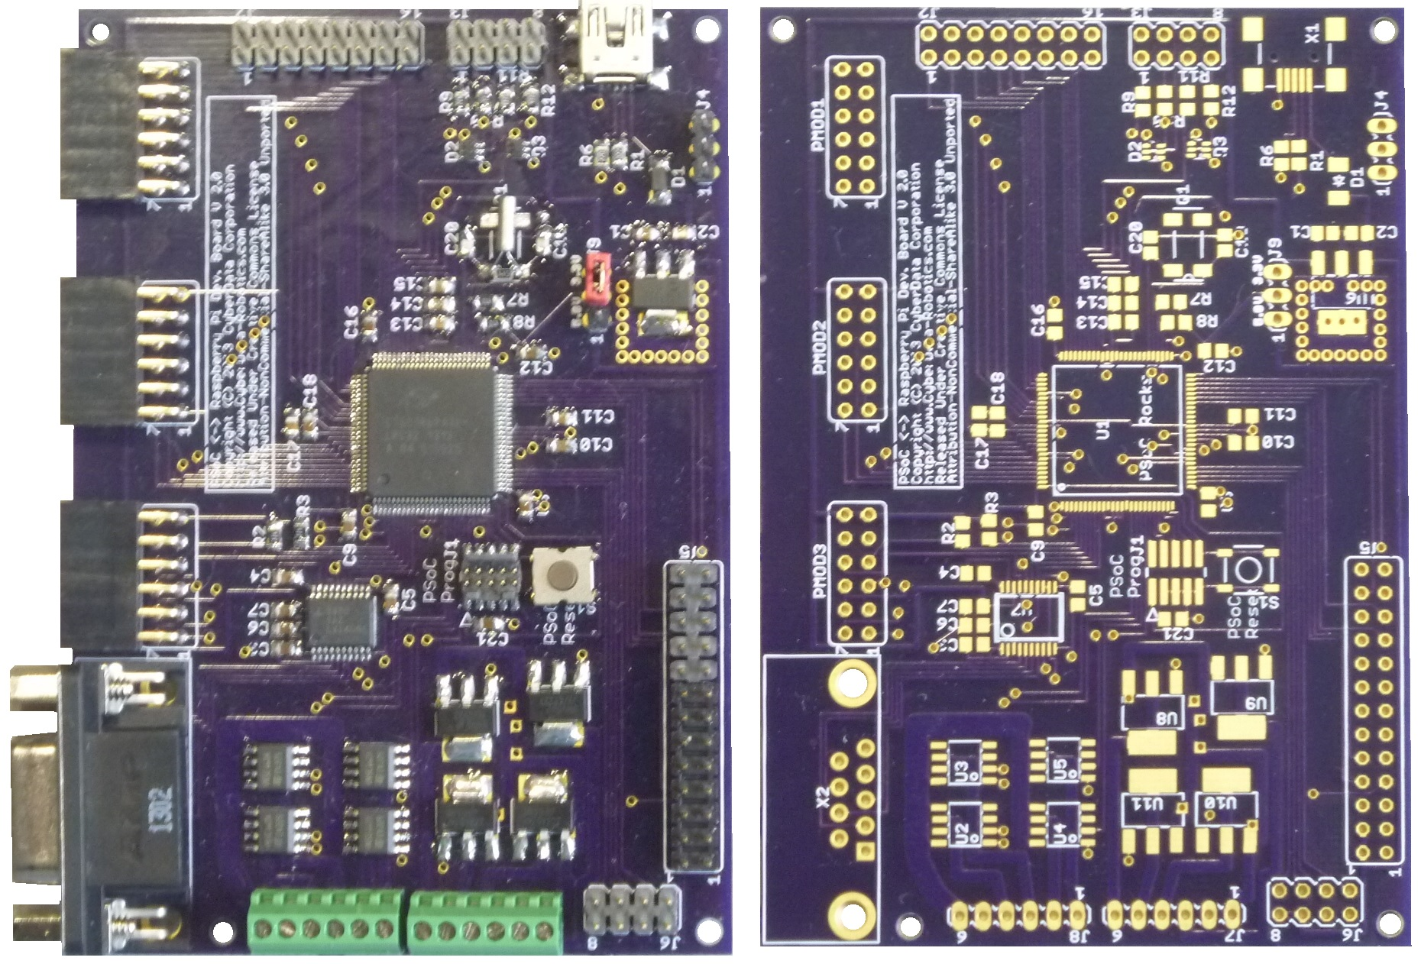
The RPi-DEV board is designed to be a flexible development and prototyping platform for both the Raspberry Pi and PSoC ecosystems. The board has the functionality needed for real time embedded projects. The heart of the board is a Cypress PSoC processor allowing user programmable analog and digital circuitry based on the target project. The board has 8 high current drivers which form a configurable motor controller, RS-232/485 driver, 3 Diligent PMOD connectors, and 18 additional I/O.

Raspberry Pi / PSoC Development Board Features:
- Open Source – All designs and documention are released under the Creative Commons, Attribution-NonCommercial 3.0 Unported License.
  - Full license text available at:
    - http://creativecommons.org/licenses/by-nc/3.0/deed.en_US
- Sample software released under GNU GPL V 3
- Compatible with all current Raspberry Pi models
- Provides the Raspberry Pi with configurable I/O for interfacing with the real world and a dedicated processor for real time applications
- Multiple Cypress PSoC processor options including the PSOC 5LP
  - 67 MHz 32 bit ARM Cortex M3 w. 256KB Flash & 64KB SRAM
  - High precision, configurable analog subsystems
    - 2x12 bit 1 Msps SAR ADC & 20 bit DelSig ADC
    - 4 precision op-amps, 4 Comparators
    - Mux, PGA, TIA, mixers, sample/hold, level shifters, V/IDAC, CapSense, and more.....
  - 24 Universal Digital Blocks
    - Counters, Timers, UART, I2C, SPI, CRC
    - PWM, motor controllers
    - VERILOG programmable for anything else you can imagine
  - Library with over 80 preconfigured peripherals
  - USB 2.0 Full Speed
  - Programmable Digital Filter Block & Filter Design Wizard
- 3x 12 pin Diligent PMOD connectors (24 I/O total)
  - Can also be used as general purpose I/O
- Standard RS-232/485 driver on a standard DB9 connector
- 4 Protected I/O lines (+/- 25V)
- 6 General I/O lines, 4 with 25mA current sink capability
- 8 Precision analog I/O lines (can also be used for additional digital I/O)
- Programmable / configurable motor controller
  - 4 low side drivers and 4 high side drivers
- Attaches to the Raspberry Pi I/O connector or can be used standalone with USB communication to a standard PC
- Powered by either the Raspberry Pi or USB port
- Supports the Raspberry Pi communications on the I/O header to PSoC
  - SPI, UART, I2C

Table of Contents:
Raspberry Pi / PSoC Development Board Features: 1
Table of Contents: 2
License: 2
Block Diagram: 3
Functional Description: 3
POSC Processor 4
Analog I/O 4
Protected I/O 4
USB Interface 6
Raspberry Pi Connection 6
Configurable Motor Controller 6
Diligent PMOD Connectors 8
Crystals and Clocking 8
Sample Code 9
PSoC Sample Application 9
Raspberry Pi Sample Application 11
Additional Reference Material: 14
Contact Information: 15
Datasheet Revision History: 15
Limitations and Disclaimers: 15

License:
All designs and documentation for this system are released under the Creative Commons Attribution-NonCommercial 3.0 Unported License. The full text of this license is available at: http://creativecommons.org/licenses/by-nc/3.0/legalcode

The sample software for this project is released under the GNU GPL Version 3.0 license. The full text of this license is available at: http://www.gnu.org/licenses/gpl-3.0.html

You are free to:
- Share the design and documentation
- Adapt this design and documentation to your own needs
Under the following conditions:
- You maintain the original copyright notice of CyberData Corporation including the URL to the company web site
- You do not use this work for commercial purposes

If you are interested in using this work for commercial purposes, please contact CyberData Corporation at http://www.CyberData-Robotics.com and obtain a commercial license for your project.

Block Diagram:
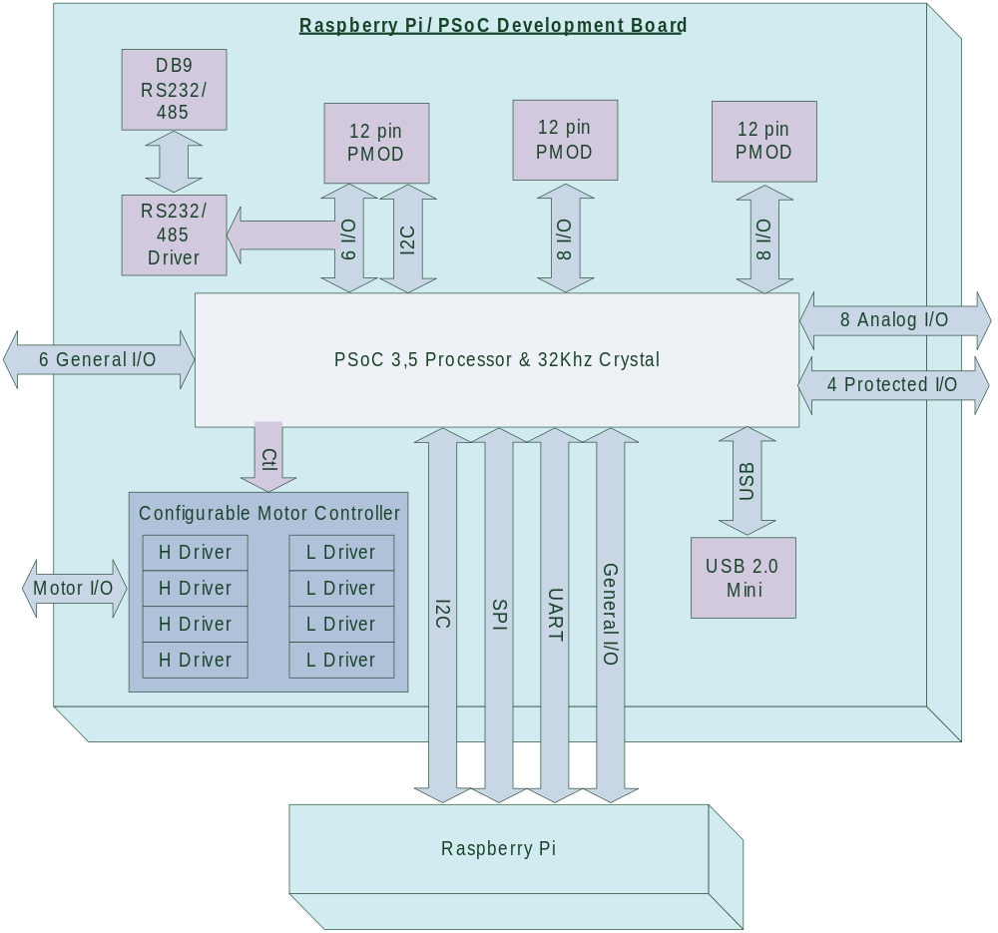

Functional Description:
The RPi-DEV board is designed to be a flexible development and prototyping platform for both the Raspberry Pi and PSoC series processors. In general the board is designed to be used in the context of robotics applications though by no means is limited to these applications.

The board is comprised of different functional blocks that may be utilized as needed to develop applications. Those blocks that are not needed do not need to be populated on the board or configured in the software.

POSC Processor
The PSOC processor forms the heart of the RPi-DEV board. Cypress produces several processors which are pin compatible, and therefore may be used on this board interchangeably. The two compatible families are the PSOC 3 and PSOC 5 (LP) processors, all with 100 pin TQFP packages. These contain an enhanced 8051 core, or ARM Cortex M3 core respectively. The specific peripherals and speeds of the chips also vary. While a CY8C5868AXI-LP032 processor is specified, any pin compatible Cypress processor may be used.

Analog I/O
Connector J2 contains 8 lines intended to be used for precision analog input and outputs. As many of these lines as possible have been connected directly to the PSoC processor analog components. IDAC0, IDAC2, OPAMP0 and OPAMP2 from the PSoC are fully available on these lines.

Voltages on the Analog I/O lines should be limited to 0 to 3.3VDC as the voltage domain for the I/O lines is supplied by the on board 3.3V regulator.

Analog I/O which is not being used in analog mode is available for controlling digital devices. It should be noted that in this case, noise from the digital signals may be injected into the analog subsystems, and care should be taken to minimize this effect.

Protected I/O
Each line on the Protected I/O header, J3, is protected to +/-25V allowing the line to be used in harsh electrical environments. The protection itself consists of a 4.7K current limiting resistor and input clamping diodes to ground and the 3.3V supply as shown:
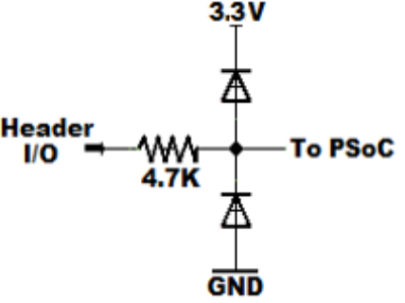

These lines may be used for input or output as desired and configured in the PsoC processor. In some applications it may also be desirable to bypass or alter the value of the 4.7K resistor. If the resistor value is altered the allowable voltage on the lines will also be changed proportionally.

USB Interface
The mini USB connector on the board connects to the dedicated USB peripheral inside the PSoC. As such the port will support all functions and modes supported by the PSoC peripheral. Power may also be supplied to the board from this connection. A blocking diode is present on the board that will prevent both the Raspberry Pi and USB connector from interacting should power be available through both connectors.

The simplest and most common use for this connection is when running the RPi-DEV board without using the Raspberry Pi, using the port to implement a CDC device for communications with a host computer. The host is typically a PC running Windows, Mac OS, or Linux. Operating in this manner both power for the RPi-DEV board and communications to the host computer are established with an industry standard connection.

Raspberry Pi Connection
Connection to the Raspberry Pi is made using connector J5. The connection can be made by either plugging directly into the board or with the use of a ribbon cable. In the case of a ribbon cable it is recommended to keep the cable length as short as possible. In general the intent of the connection to the Raspberry Pi is to pass command level information between the two processors using either the UART or I2C communications, and pass streaming information using the SPI interface.

When using the Raspberry Pi connection ensure that J9 is set for 3.3V operation. Failure to do so will apply 5V to the I/O lines connected to the Pi and will damage the Pi!

For applications not using the Raspberry Pi, jumper J9 may be set to the 5V position. This configuration allows the Raspberry Pi I/O lines to be used as general I/O lines, and also allows for level shifting.

Two of the discrete I/O lines from the Raspberry Pi connector have also been connected to the PsoC processor.

Configurable Motor Controller
The Configurable Motor Controller is comprised of 4 high side switches, 4 low side switches and configurable logic inside the PSoC processor. The intent of this subsystem is to allow for a variety of high current applications. A functional motor controller is achieved by combining the following resources:

Low Side Switches:
Four low side switches are provided on connector J7. Each low side switch is comprised of a VNN3NV0P switch and is independently controlled by the PSoC processor. Each VNN3NV0P switch is capable of switching 3.5A at 40VDC, and includes the reverse biased diode for driving inductive or capacitive loads. The driver is also over-current, over-voltage and over-temperature protected. Note that a heat sink may be required to achieve the full current range of the device.

High Side Switches:
Four high side switches are provided on connector J6. Each high side switch is comprised of a VN5160S switch and is independently controlled by the PSoC processor. Each VN5160S switch is capable of switching 5.4A at 41VDC, and includes the reverse biased diode for driving inductive or capacitive loads. The driver is also over-current, over-voltage and over-temperature protected. Note that a heat sink may be required to achieve the full current range of the device.

PSoC Logic:
The programmable nature of the motor controller comes from leaving the control logic inside the PSoC processor, thus allowing it to be configurable based on application needs.

In simple cases the drivers may be used individually to simply switch individual loads on and off. It is also possible that unused drivers are not populated and simply jumpered out on the IC pads. Up to 8 motors or solenoids can be controlled in this fashion.

H-Bridges can be easily constructed by using two high side switches in combination with 2 low side switches. The logic to then coordinate the drivers is programmed into the PSoC processor USB blocks. This may also be combined with the standard PWM peripheral components to provide both direction and speed control. Drivers of this form can contain considerable complexity including dead bands, braking and regenerative functions. Sufficient drivers are provided to build up to two H bridge motor controllers. The sample code contains a dual H-Bridge controller with dual PWM controls. This sample can easily be connected to two DC motors to control a simple robot.

Stepper motors may also be controlled using the various switches. Sufficient drivers are present to control a single four phase – bipolar stepper motor. Two uniphase motors could also be controlled by placing one on the high side switches and one on the low side switches. Finally microstepping is possible using PWM peripherals inside the PSoC along with the high current drivers.

If the on board drivers do not have sufficient voltage or current capacity they will make excellent first stage drivers for off board switches where larger devices and heat sinks may be used.

Diligent PMOD Connectors
A total of 3 standard twelve pin PMOD connectors are provided allowing for a wide range of commercially available sensors and I/O devices to be plugged directly into the RPi-DEV board. These connectors are labeled PMOD1 through PMOD3. PMOD3 is special in that the PSOC dedicated I2C communication lines are routed to this connector and other lines are shared with the RS232/485 driver. If you are planning to use an I2C interface, it would be beneficial to place that communication channel on the PMOD3 connector and use the dedicated hardware inside the PSOC for this purpose. Note that I2C devices may be used on any of the PMOD connectors, as desired, but will not make as efficient use of PSOC resources as the PSoC dedicated hardware.

Signal lines to the PMOD3 connector are also routed to a RS-232/485 driver IC and from there to a standard DB9 connector on the board to provide the industry standard interfaces. When used with the driver IC the PMOD connections should generally be left unconnected. Note that given the connections on the board the PMOD connector makes a very convent debugging connection for a logic analyzer, or other communications monitor.

The UART on the Raspberry Pi can be directly routed through the PSOC processor to the RS232/485 driver by making the needed connections between the Raspberry Pi connected signals and the PMOD connected signals using the signal fabric of the PSOC processor. This will allow the Raspberry Pi to directly communicate with standard RS-232 / RS-485 devices with no software overhead. The sample code contains an example of this configuration, allowing the Raspberry Pi to directly communicate with a standard 3-wire RS-232 device. The sample can be easily modified to also allow for RS-485 communications.

Crystals and Clocking
A 32.768KHz crystal is provided for operating the kHzECO system of the PSOC processor as this enables fundamentally unique functionality on the processor (specifically the sleep timer and RTC). If these features are not needed the 32Khz crystal and associated capacitors may be left unpopulated.

It was a conscious decision to not support the PSoC MhzECO crystal at this time for the following reasons:
- The primary purpose of the MhzECO is precision operation, not additional functionality (The IMO can provide +/-1% to +/-7% accuracy)
- Depending on the precision required for the specific application multiple solutions would be needed, hence any simple solution may not be suitable in a specific case
- This is an open source board, and anyone needing the MhZECO can easily add whatever is specifically needed for their application

Sample Code:
A sample code package is currently available to provide a starting point for custom applications and to also configure basic resources the PSoC. The sample code consists of two applications, one for a PSoC 5LP processor and the second for the Raspberry Pi. The application sets up an easily configurable SPI communication channel between the Raspberry Pi and the PSoC processor, configures a simple dual channel PWM DC motor controller, and provides routing of the Raspberry Pi UART from the Raspberry Pi I/O connector through the RS-232/485 driver to the DB9 connector on the board.

PSoC Sample Application
The sample application for the PSoC is called BotPsoc and is a standard PSoC Creator 3.0 application. The application defines and configures 4 general resources as starting points for your own applications:
- SPI Communication Ring between the PSoC and Raspberry Pi
- RS-232 buffer passing through the PSoC processor of the Raspberry Pi I/O connector UART
- Dual channel DC motor controller, each comprised of an H-bridge and PWM controller
- 8 Debugging I/O lines

SPI Communication Ring:
The SPI communication ring is intended to provide an example of a high speed, efficient communication channel between the PSoC and Raspberry Pi processors. The ring itself connects the SPI peripheral on the Raspberry Pi I/O connector to a DMA assisted SPI Slave component on the PSoC.

The Raspberry Pi application program initiates a binary, symmetric transfer of a user defined C structure between the two processors every 50mS. During this transfer the C structures for the two processors are simply copied to from one processor to the other. The C structure itself is defined in …/common/ringcoms.h. The communication structure is currently defined in terms of a simple two wheel robot with various sensors. On each transfer cycle the members of the SensoryMembers are copied from the PSoC processor to the Raspberry Pi processor, while at the same time the members of the MotorMembers structure are copied from the Raspberry Pi processor to the PSoC processor. The names and number of fields can be changed for whatever application is desired. Note the size of the incoming and outgoing structures must remain identical as they are transferred at the same time by the SPI subsystem. If necessary one structure or the other will need to be padded with unused members to make the size equal.

On the PSoC side the SPI transfer is handled by DMA for optimum use of the processor resources.

The code configuring and controlling the SPI peripheral on the PSoC is located in the files spi_ring.h/.c The SPI transfer is controlled by the SPI master on the Raspberry Pi. When a transfer is completed the flag g_spiReady is set signaling new data is available. The main() routine in the file main.c shows an example of polling this flag, setting up a transfer and then reading the resulting information back. In this case parsing out and sending commands to the motor controllers. It is also possible to directly hook the interrupt setting the g_spiReady flag and call your own handler directly instead of polling.

RS-232 Pass-through:
The RS-232 pass-through is currently a hardware only mapping between the signals available on the Raspberry Pi I/O connector and the RS-232/485 driver located on the development board. The mapping is shown on page 1 of the TopDesign.cysch document. Constants are mapped to the various control lines of the driver chip, turning it on and configuring it for RS-232 communications. The intent here is to show a simple starter example which provides some nice functionality.

Dual Channel DC Motor Controller:
Page 2 of the TopDesign.cysch shows the hardware detail for the dual channel DC motor controller. The controller itself is comprised of a control register and two symmetrical driver circuits. The actual drivers on the development board and hookup to the DC motors is also shown on the schematic in “Off-Chip” form. Source code for the motor drivers is contained in the files base_motion.h/.c The motor controller can be updated with a simple function call of:

baseMotion_Update(uint8_t motorCommand, uint16_t rightSpeed, uint16_t leftSpeed)

where:

motorCommand: A set of bit fields which control the motor states
0: Right motor direction (1 = forward)
1: Right motor brake (1 = motor windings shorted)
2: Left motor direction (1 = forward)
3: Left motor brake (1 = motor windings shorted)
rightSpeed: The PWM value controlling the speed of the right motor
leftSpeed: The PWM value controlling the speed of the left motor

Debugging I/O Lines:
8 I/O lines are currently allocated simply for debugging applications. In general use these lines are connected to either a logic analyzer or oscilloscope at the pins of the board. Internally the lines are then either toggled by software or connected into the electrical configuration as needed for the current debugging effort. The components for each debug pin are located on page 1 of TopDesign.cysch. The pin allocations are:

Schematic Name | Processor Port[bit] | Board Connector & Pin
Debug0 | P12[2] | J3 pin 6
Debug1 | P12[3] | J3 pin 8
Debug2 | P4[4] | PMOD1 pin 1
Debug3 | P4[5] | PMOD1 pin 2
Debug4 | P4[6] | PMOD1 pin 3
Debug5 | P4[7] | PMOD1 pin 4
Debug6 | P6[0] | PMOD1 pin 7
Debug7 | P6[1] | PMOD1 pin 8

Raspberry Pi Sample Application
The sample application for the Rasperry Pi is called BotMonitor. The goal of the application is to provide a simple UI for the SPI ring communications and to drive the SPI ring communications using the Raspberry Pi SPI Master.

This application is intended to build under Qt 4.8.x and run on the Raspberry Pi. It is also recommended that the Raspberry Pi be configured according to the talk “Getting Started with Rasperry Pi” located here: http://www.cyberdata-robotics.com/Presentations/StartingPi/StartingRaspberryPi.pdf
This presentation will show you how to install Qt on the Raspberry Pi as well as configure the serial port in the manner necessary for use with this application. Current versions of the Raspian OS now come with the SPI drivers and needed configuration for this application.

Main.h/.cpp
This main() routine simply creates a BotMonitor UI object and displays it like any other typical Qt application.

BotMonitor.h/.cpp
This class represents the main window for the application. When the class is instantiated the UI is set up and a SpiRing class is allocated. The SpiRing class will emit a Qt signal named newTransferReceived() each time an exchange of information is completed over the SPI ring. This signal is connected to the BotMonitor slot named processSpiUpdate(). Each time this slot is called information from the sensor portion of the SPI data structure is read from the buffer and placed into the UI. Information from the UI is then copied into the motor side of the SPI buffer to await transfer to the PSoC processor on the next exchange.

spi_ring.h/.cpp
The SpiRing class represents the actual data and exchange mechanism for the SPI ring system. When the class is created the SPI Master hardware of the Raspberry Pi is configured and a Qt timer is started. When the timer expires the function SpiRing::beginTransfer() is called to perform the actual transfer.

SpiRing::beginTransfer() double buffers information between the actual hardware transfer buffers and the data structures for general program use. During this transfer a mutex is locked to prevent data corruption. The transfer is then started on a new thread to run in the background. This is done as the current Raspberry Pi SPI drivers are not DMA based. Once the transfer is completed the information is copied back to the general data structures and the thread terminates.

The transfer timing is controlled by the variable QTimer SpiRing::m_autoTransferTimer. The interval for this timer can be changed by altering the define SPI_RING_TRANSFER_INTERVAL, which is specified in spi_ring.h and is expressed in milliseconds.

The bit rate of the SPI Master can be controlled by setting the define SPI_SPEED in spi_ring.h. Currently this value is set to 4MHz which is the maximum value supported by both the PSoC SPI Slave peripheral (5MHz) and the Raspberry Pi SPI peripheral, which can only be changed in increments of 2x. If you are experiencing transfer errors on the SPI ring there are two simple approaches:
- Shorten or shield the cable between the Raspberry Pi I/O connector and the development board.
- Lower the bit rate of the SPI transfer

Additional Reference Material:

RPi-DEV Supporting Materials
RPi-DEV Web Site: http://www.cyberdata-robotics.com/RPi-Dev

PDF Datasheet: http://cyberdata-robotics.com/Products/RPi-Dev/RPi-Dev%20Datasheet.pdf

Engineering Bundle (Eagle CAD PCB, BOM, Schematic & Software): https://github.com/LloydMoore/RPi-Dev

Raspberry Pi Supporting Materials
Home Page: http://www.raspberrypi.org/

Schematics: http://www.raspberrypi.org/wp-content/uploads/2012/10/Raspberry-Pi-R2.0-Schematics-Issue2.2_027.pdf

OS Image Downloads: http://www.raspberrypi.org/downloads

Getting Started with the Raspberry Pi Slide Deck: http://www.cyberdata-robotics.com/Presentations/StartingPi/StartingRaspberryPi.pdf

IC Datasheets
PSoC 5LP: http://www.cypress.com/psoc5lp/

PSoC 3: http://www.cypress.com/psoc3/

ISL3330IAZ RS-232/485 Driver: http://www.intersil.com/content/dam/Intersil/documents/fn63/fn6361.pdf

VN5160S High Side Switch: http://www.st.com/st-web-ui/static/active/en/resource/technical/document/datasheet/CD00159300.pdf

VNN3NV04P-E Low Side Switch: http://www.st.com/web/en/resource/technical/document/datasheet/CD00002208.pdf

Development Sofware Links
Qt Home Page: http://qt-project.org/

PSoC Creator 3.0 Home Page: http://www.cypress.com/psoccreator/

Contact Information:

Physical Address:
CyberData Corporation
1327 S. Puget Drive #F24
Renton, WA 98055

Company Web Site:
www.CyberData-Robotics.com

E-Mail:
Lloyd@CyberData-Robotics.com

Datasheet Revision History:

Document Revision | Date | Description
1.0.0 | 01/09/14 | Initial document construction

Limitations and Disclaimers:
The information contained here in is subject to change without notice. CyberData Corporation assumes no responsibility for the use or misuse of this information other than embodied in a CyberData product. Nor does it convey or imply any license under patent or other rights. CyberData products are not warranted nor intended to be used for medical, life support, life saving, critical control or safety applications, unless pursuant to an express written agreement with CyberData. Furthermore CyberData does not authorize its products for use as critical components in life support systems where a malfunction or failure may be reasonably expected to result in significant injury or death to the user, bystanders or other individuals. The inclusion of CyberData products in life support systems, life saving, critical control or safety applications implies that the manufacturer of said equipment assumes all risk of such use and in doing so indemnifies CyberData Corporation against any and all charges.

CyberData Corporation MAKES NO WARRENTY OF ANY KIND, EXPRESS OR IMPLIED, WITH REGUARD TO THIS MATERIAL, INCLUDING BUT NOT LIMITED TO THE IMPLIED WARRANTIES OF MERCHANTABILITY AND FITNESS FOR A PARTICULAR PURPOSE. CyberData reserves the right to make changes with further notice to the materials described herein. CyberData does not assume any liability arising out of the application or use of any product or circuit described herein.

Use may be limited by and subject to the applicable CyberData Corporation software license agreement(s).

